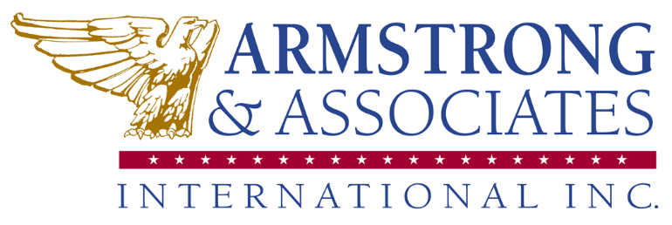
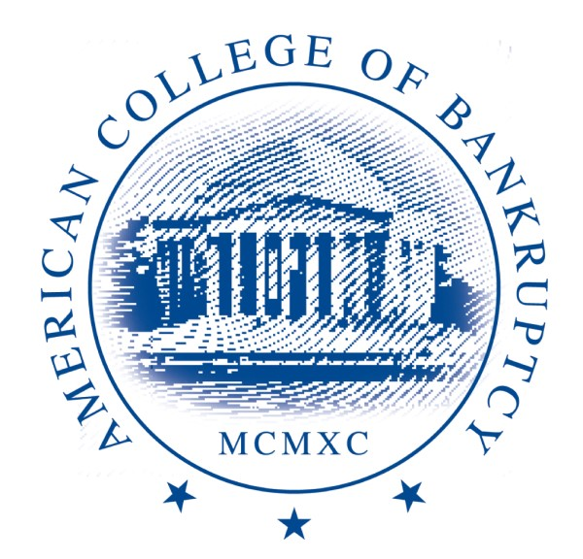

Complaint Resolution Policy (as of June 28, 2021)
Armstrong & Associates International , Inc. (A&A) DBA American College of Bankruptcy welcomes feedback from all participants on behalf of our clients A&A seeks to ensure equitable treatment of every person and to make every attempt to resolve grievances in a fair manner.
Any issues regarding a particular conference or course should be directed to Administrative Specialist and Continuing Education Coordinator Jenny Cudahy at jcudahy@amercol.org. All grievances are kept confidential and all persons are treated with respect and kindness as the parties involved work to resolve the grievance. If the resolution is not satisfactory remains unresolved, it will be directed to the Executive Director, Shari Bedker, at sbedker@amercol.org. Individuals not satisfied with a resolution provided by A&A have the option to appeal to the Board of Directors of the A&A client that hosted the event.

