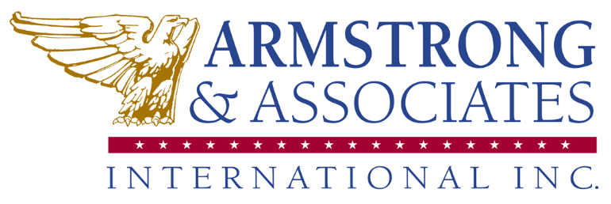
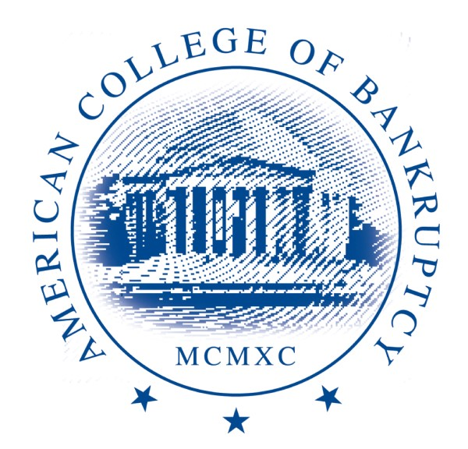

Program Cancellation Policy (as of June 28, 2021)
If Armstrong & Associates International, Inc. (A&A) DBA the American College of Bankruptcy and its clients are unable to meet in person due to health and safety issues, including, but not limited to, COVID19, local government travel restrictions, weather, earthquakes, etc., we will transition to a virtual event. All registration fees for the in-person event will automatically be transferred to the virtual conference.

Our Program Cancellation Policy is as follows:
If Armstrong & Associates International, Inc. (A&A) and its clients need to cancel an event, workshop, or seminar, participants will be notified prior to the day of the scheduled workshop and will issue refunds to all participants registered for that program within two (2) weeks of the cancellation date. All deposits will be refunded IN FULL if a workshop is cancelled due to low enrollment, instructor scheduling conflicts or causes beyond our control. We reserve the right to cancel events, workshops, or seminars that do not meet minimum registration requirements.

