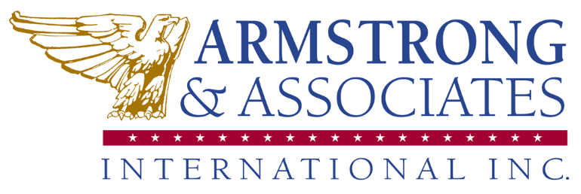
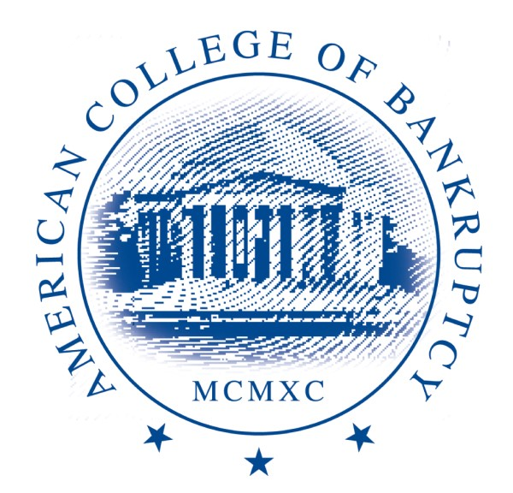

Refund Policy (as of June 28, 2021)
If Armstrong & Associates International, Inc. (A&A) DBA the American College of Bankruptcy and its clients are unable to meet in person due to health and safety issues, including, but not limited to, COVID19, local government travel restrictions, weather, earthquakes, etc., we will transition to a virtual event. All registration fees for the in-person event will automatically be transferred to the virtual conference.

Our cancellation and refund policy is as follows:
All cancelation notices and refund requests must be in writing and submitted to Jenny Cudahy, jcudahy@amercol.org at least five business days before the event begins. No refunds will be granted once the event begins. However, you may transfer your ticket to the next scheduled conference or to a colleague. For substitutions, please submit the current guest’s name and substitute’s name and email address to jcudahy@amercol.org

Because of venue contractual obligations, there are no refunds for no-shows.

